2008
Higher School Certificate
Preliminary Examination

Biology

General Instructions  Reading time – 5 minutes  - Working time – 2 hours  - Write using black or blue pen  - Draw diagrams using pencil  - Board-approved calculators may be used  - Write your student number and/or name at the top of every page | Total marks – 75  Section I – Pages 2 – 8  Total marks (15)  Attempt Questions 1 – 15  Allow about 30 minutes for this section  Section II – Pages 9 – 18  Total marks (60)  Attempt Questions 16 – 27  Allow about 1 hour 30 minutes for this section
This paper MUST NOT be removed from the examination room

Section I

Total marks (15)
Attempt Questions 1–15
Allow about 30 minutes for this section

Select the alternative A, B, C or D that best answers the question and indicate your choice with a cross (X) in the appropriate space on the grid below.

 | A | B | C | D
1
2
3
4
5
6
7
8
9
10
11
12
13
14
15

1. Which abiotic factor is essential for the survival of photosynthetic organisms in aquatic environments?

- Light
- Temperature
- Wind exposure
- Viscosity

2. The graph below shows breeding population estimates of the southern elephant seal (Mirounga leonina) at Australia’s Macquarie Island .

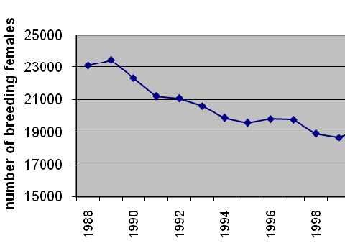

What trend does this graph show?

- Southern elephant seal numbers may increase or decrease.
- The population is stable and the number of southern elephant seals is steady.
- The number of breeding females is decreasing and therefore population numbers will probably decline.
- The number of breeding females is increasing and therefore population numbers are likely to increase.

3. What contribution did Robert Hooke make to the development of cell theory?

- He discovered that all cells contained a structure called the nucleus.
- He first observed dead cells in cork using a simple microscope.
- He suggested that cells are the fundamental unit of life and that all living things are made of cells.
- He was the first to observe and draw “animalcules” in pond water using a simple microscope

4. Why are mitochondria found in large numbers in muscle cells of animals?

- Mitochondria produce proteins, the building blocks of all muscle tissue.
- Mitochondria are responsible for excreting the large amount of wastes that accumulate during exercise.
- Respiration occurs in the mitochondria. This releases energy for muscles to function.
- Storage of essential nutrients such as glucose, needed for muscles to function, occurs in the mitochondria.

5. Why is the use of teeth to chew food an important part of the digestive process?

- Chewing food reduces the need for further digestion by enzymes.
- Chewing helps to break down complex molecules such as starch.
- Chewing food into smaller pieces helps to decrease the surface area over which enzymes act.
- Chewing food into smaller pieces helps to increase the surface area over which enzymes act.

6. Methanogens, a type of Archaebacteria, were thought to be abundant in the environment of early Earth.

Why are they now only found in swamps, bogs and sewage?

- Methanogens have been outcompeted by more modern forms of bacteria and now survive only in these places.
- Methanogens rely on nutrients found only in swamps, bogs and sewage.
- Swamps, bogs and sewage are the same as the environment of early Earth.
- Swamps, bogs and sewage have very little oxygen and methanogens cannot live in an environment with oxygen.

7. Which of the following supports the theory that Australia was once part of a landmass called Gondwana?

- Gondwanan continental margins fit together like a jigsaw puzzle.
- Unique flora and fauna are found on the Australian continent.
- Mammals such as rats (genus Rattus) are found on other Gondwana continents.
- There is a lack of common fossils on other Gondwanan continents.

8. The picture below shows specialised tissue from a plant.

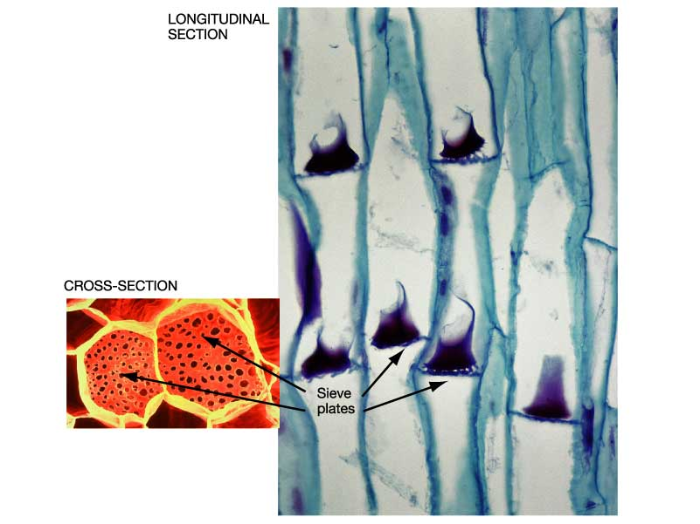

What are these cells likely to be?

- Phloem cells
- Epidermal cells
- Mesophyll cells
- Xylem cells

9. The Australian bottlebrush (genus Callistemon) produces a flower with a strong scent and sweet sugary nectar.

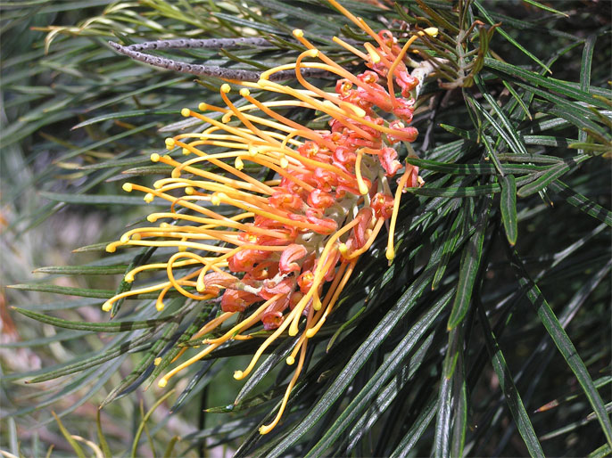

What would be the most likely method of pollination for this plant?

- Wind
- Self
- Animal
- Water

10. The oldest known fossils occur in cherts (flint-like rocks) dated at about 3,500 million years old in South Africa and the Pilbara region of Western Australia. What are these fossils most likely to be?

- Eukaryotic cells with organelles
- Prokaryotic cells with organelles
- Prokaryotic cells without organelles
- Eukaryotic cells without organells

11. Which of the following would be expected to be most closely related?

- Two organisms in the same Kingdom
- Two organisms in the same order
- Two organisms in the same class
- Two organisms in the same species

12. Why is variation within a species important for its survival?

- If environmental conditions suddenly change some organisms may have characteristics that provide a survival advantage.
- If environmental conditions remain the same for long periods the better adapted organisms are more likely to die out.
- Variation within a species encourages interbreeding with other members of the same species.
- Variation within a species encourages interbreeding with other members of different species.

13. Observe the food web of a mud flat ecosystem below:

Pelican
Humans
Large fish
Prawns
Zooplankton
Crabs
Phytoplankton
Seagrass
Small fish

What would be the immediate consequence if all the seagrass died?

- Large fish would increase in numbers.
- Small fish would all die out.
- Zooplankton numbers would decline.
- Pelican numbers would decline.

14. What is the role of mitosis in an organism?

- To produce diploid gametes
- To produce diploid somatic cells
- To produce haploid somatic cells
- To produce haploid gametes

15. What was the significance of the Urey and Miller experiments in debate on the composition of Earth’s primitive atmosphere?

- They proved that life could be generated from hydrogen, methane and ammonia if an electrical charge was passed through them.
- They provided a model to support the hypothesis that simple organic molecules could be produced from inorganic ones.
- They proved that organic molecules originated from outer space when meteorites “seeded” the Earth.
- They proved that no life could have existed in the toxic environment of Early Earth.

Section II

Total marks (60)
Attempt Questions 16–27
Allow about 1 hour and 30 minutes for this section

Answer the questions in the spaces provided.

Question 16 (4 marks) Marks

The photograph below shows a road running over a creek.

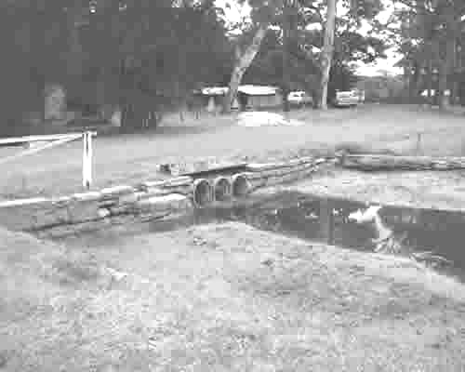

(a) Identify TWO human impacts on this ecosystem. 2

(b) Explain the effect on the ecosystem of each of the impacts mentioned in (a). 2

Question 17 (4 marks) Marks

Complete the table below. 4
Major chemical group found in cells | Use of this chemical group in cellular activities
Lipids
 | This chemical is arranged into genes – the units of inheritance. It provides the blueprint for the manufacture of proteins and other essential polypeptides.
Proteins
 | These are the major source of energy for the cell, the simplest being sugars. They also make up cell walls in plant cells(cellulose)

Question 18 (5 marks)

Discuss, using specific examples, how developments in scientific knowledge may conflict with other ideas and theories about the origin of life. 5

Question 19 (5 marks) Marks

To estimate the population of leaf-eating beetle (order Coleoptera) on river red gum eucalypt foliage, a cotton sheet was placed below a tree and the branches shaken. Fallen beetles were then counted, tagged with a spot of paint, and released. (Time 1)
The process was repeated 24 hours later and the number of captured and recaptured beetles was noted (Time 2).

The results are shown below:
Non-tagged beetle
Tagged beetle
Time 1
Time 2
Capture-recapture survey of beetle population

(a) Use this information to estimate the beetle population of the river red gum eucalypt sampled. (show working) 4

(b) Propose a way of improving the reliability of your beetle population estimate. 1

Question 20 (6 marks) Marks

The diagram below represents stages of a cellular process.

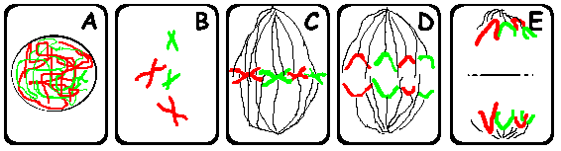

(a) Explain what is happening at each stage. 4

(b) Where are you most likely to find this process occurring in a plant? 2

Question 21 (4 marks) Marks

Phoenix scientists will soon analyse Martian ice

WASHINGTON (AFP) — Scientists with the US Phoenix Lander will make their first analysis of Martian ice fragments in coming days, NASA said on its website Friday.

On June 20, NASA scientists announced that the Phoenix Mars Lander confirmed a long-held belief that ice is hiding under the surface in the Red Planet's northern region.

NASA scientists said they will analyse ice fragments in the TEGA oven; if the ice contains impurities the results could speak volumes of the climate history in that area of the Red Planet.

Mars is currently too cold for water to flow, but it is possible that in a distant past the polar regions saw higher temperatures and had liquid water, according to the scientists.

Phoenix's mission is to search for water and organic components to see if a primitive form of life was possible on Mars.

Discuss the implications for our understanding of the origins of life on Earth if organic molecules are discovered in the ice fragments on Mars. 4

Question 22 (9 marks) Marks

Design a first-hand investigation to demonstrate the relationship between surface area and
rate of reaction. 9

In your answer:

- Identify the dependant and independent variables.
- Identify any other variables that need to be kept constant.
- Include a risk assessment.
- Describe any relevant graphs, diagrams or data.

Question 23 (7 marks) Marks

The diagram below is of Euglena. This unicellular organism has a flagellum for movement, a primitive eyespot but also a chloroplast and is able to photosynthesise. Euglena can also absorb nutrients from the surroundings.

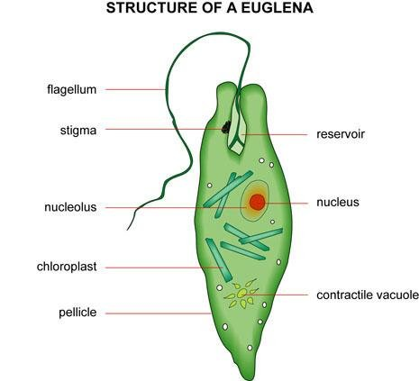

(a) Explain why it would be difficult to classify Euglena using the two Kingdom classification system. 3

Question 23 continues on the next page

Question 23 (continued) Marks

(b) Which Kingdom would it belong to under the five Kingdom classification system?
Justify your answer. 3

(c) If you were asked to construct a dichotomous key to help classify this organism, what selection criteria would you begin with? 1

Question 24 (6 marks)

Discuss TWO theories to account for the change in Australian biota over time. 6

Question 25 (3 marks) Marks

Complete the following table. 3

Reproductive method | Internal fertilisation | External fertilisation
Where it occurs |  | Occurs outside the body -usually in water
Number of gametes produced | Few
Example of an Australian organism | Kangaroo

Question 26 (4 marks)

Describe the conditions under which asexual reproduction is advantageous.

Give TWO examples of organisms that use this method of reproduction. 4

Question 27 (3 marks) Marks

Why is it important to maintain biodiversity? 3

End of paper

